Tender Covering Form
Directorate of Procurement (Navy)
Through Bahria Gate
Near SNID Center, Naval Residential Complex, E-8, Islamabad
Contact: Reception 051-9262311, Bahria Gate 0331-5540649, Section
Tender No & Date ________________________________________________
Tender Description ________________________________________________
IT Opening Date ________________________________________________
Firm Name ________________________________________________
Postal Address ________________________________________________
Email Address for Correspondence____________________________________
Contact Person Name_______________________________________________
Contact Number (Landline __________________) (Mobile _____________)
Documents to be Attached with Quotation
Firm is to submit its proposal in a sealed envelope which shall contain 03 x Sealed Envelops as per details given below:
Sealed Envelop 1 – Technical Offer in Duplicate
This envelope must contain 02 x sets of Technical Offer (01 x Original + 01 x Copy). Each Set must contain following documents as per this order and Supplier is to mark tick against each to ensure that these documents have been attached:
S No | Document |  | Original Set | Copy Set
1. | Bank Challan
2. | Principal Authorization Letter (where applicable)
3. | Principal Invoice (Muted – without Price) (where applicable)
4. | DP -1 Form of IT (with compliance remarks)
5. | DP – 2 Form of IT with compliance remarks against each clause
6. | Technical Offer / Specs
7. | Annexes of IT
8. | DP-3 form of IT (dully filled & signed)
9. | DGDP Registration Letter (If firm is registered with DGDP)
10. | Income Tax Filling Proof
11. | Sales Tax Registration Proof
Sealed Envelop 2 – Earnest Money
This Envelop must contain Earnest Money only.
Sealed Envelop 3 – Commercial Offer
This Envelop must contain following documents:
1. | Firm’s Commercial Offer | 01 x Original
2. | Principal Invoice (where applicable) | 01 x Original
3. | Dully filled DP-2 Form of IT | 01 x Original
Firm’s Declaration
It is certified that we have submitted tender in compliance with above instructions and we understand that our offer is liable to rejection if tender is not prepared / packed as per above instructions.

Firm’s Authorized Signatures _________________

DP-1

DIRECTORATE PROCUREMENT (NAVY)

Tender No……….…………………………….
Directorate of Procurement (Navy)
Through Bahria Gate
Near SNIDS Centre,
Naval Residential Complex, E-8,
Islamabad
Contact: Reception: 051-9262311
Bahria Gate: 331-5540649
Section: 051-9262302
Email: dpn@paknavy.gov.pk
adpn32@paknavy.gov.pk
M/s_________________________
____________________________
____________________________
____________________________ Date _______________________

INVITATION TO TENDER AND GENERAL INSTRUCTIONS

Dear Sir / Madam,

1. DP (Navy) invites you to tender for the supply of stores/equipment/ services as per details given in attached Schedule to Tender (Form DP-2).

2. Caution: This tender and subsequent contract agreement awarded to the successful bidder is governed by the rules / conditions as laid down in PPRA Rules-2004 and DPP&I-35 (Revised 2019) covering general terms & conditions of contracts laid down by MoDP / DGDP. As a potential bidder, it is incumbent upon you and your firm to first acquaint yourself with PPRA Rules 2004 (www.ppra.org.pk) and DPP&I-35 (Revised 2019) (print copy may be obtained from DGDP Registration Cell on Phone No. 051-9270967 before participating in the tender. If your firm / company possesses requisite technical as well financial capability, you must be registered or willing to register with DGDP to qualify for award of contract, which shall be made after security clearance and provision of required registration documents mentioned in Para 15 of this DP-1.
Understood agreed
Understood not agreed
Understood agreed
Understood not agreed
3. Conditions Governing Contracts. The ‘Contract’ made as result of this I/T (Invitation to Tender) i.a.w PPRA Rules 2004 shall mean the agreement entered into between the parties i.e. the ‘Purchaser’ and the ‘Seller’ on Directorate General Defence Purchase (DGDP) contract Form “DP-19” in accordance with the law of contract Act, 1872 and those contained in Defence Purchase Procedure & Instructions and DP-35 (Revised 2019) and other special conditions that may be added to given contract for the supply of Defence Stores / Services specified herein.

4. Delivery of Tender. The tender documents covering technical and commercial offers are to be furnished as under:-
Understood agreed
Understood not agreed
a. Commercial Offer. The offer will be in duplicate and indicate prices quoted in figures as well as in words in the currency mentioned in IT. It should be clearly marked in fact on a separate sealed envelope “Commercial Offer”, tender number and date of opening. Taxes, duties, freight/transportation, insurance charges FATs Local Training, Foreign Training, Installation Commissioning, Services Taxes etc are to be indicated separately. Total price of the items quoted against the tender is to be clearly mentioned. In case of more than one option offered by the firm, DP(N) reserves the right to accept lowest technically accepted option if more than one options were accepted in Technical Scrutiny Report.
Understood agreed
Understood not agreed
b. Technical Offer: (Where Applicable). Should contain all relevant specifications in DUPLICATE (or as specified in IT) along with essential literature/brochure, drawings and compliance metrics in a separate sealed envelope and clearly marked “Technical Offer” without prices, with tender number and date of opening. Technical offer shall be opened first; half an hour after the date and time for receipt of tender mentioned in DP-2. Firms are to confirm/comply with IT technical specification in the following format:

S.No | Technical requirement as per IT | Firm’s endorsement (Comply/ Partially Comply/ Non Comply | Basis of C, PC of NC i.e. Refer to page or brochure | In case of non availability of enclosed proof from brochure/ Literature, quote/ attach additional documents/ data/undertaking as proof of compliance
(Legend: C = Fully Comply, PC = Partially Comply, NC = Not Comply)
(Firms must clearly identify where their offer does not meet or deviates from IT Specs)

c. Special Instructions. Tender documents and its conditions may please be read point by point and understood properly before quoting. All tender conditions should be responded clearly. In case of any deviation due to non-acceptance of tender conditions(s), the same should be highlighted alongwith your offered conditions. Tender may however be liable to be rejected.
Understood agreed
Understood not agreed

d. Firms shall submit their offers in two separate envelopes (i.e. two copies of commercial offer and two or more copies of the technical offer as asked in the IT) and envelops clearly marked “Technical proposal”, “Commercial proposal” in bold. The commercial offer will include rates of items/services called for and the technical offer will not indicate the rates. Both types of offers are to be enclosed in separate covers and each envelope shall be properly sealed bearing the signature of the bidder. Each cover shall indicate type of offer, number and date of IT and IT opening date. Thereafter both the envelopes (technical and commercial offer) shall be placed in one envelope (second cover) duly sealed and signed. This cover should bear the address of the procurement agency indicating, issuance date of IT and No, with its opening date. This should be further placed in another cover (third cover), addressed and indicated in the tender documents, without any indication that there is a tender within it.
Understood agreed
Understood not agreed
e. FORM DP-1, DP-2, DP-3 and Questionnaires. Form DP-1, DP-2 (alongwith annexes), DP-3 and Questionnaires duly filled in are to be submitted with the offer duly stamped/signed by the authorized signatory/ person. It is pertinent to mention that all these are essential requirement for participation in the tender.

f. The tender duly sealed will be addressed to the following:-

Directorate of Procurement (Navy)
Through Bahria Gate, Near SNIDS Centre,
Naval Residential Complex, E-8,
Islamabad
Contact: Reception: 051-9262311
Bahria Gate: 331-5540649
Section: 051-9262302
Email: dpn@paknavy.gov.pk
adpn32@paknavy.gov.pk

5. Date and Time For Receipt of Tender. Tender must reach this office by the date and time specified in the Schedule to Tender (Form DP-2) attached. This Directorate will not accept any excuse of delay occurring in post. Tenders received after the appointed/ fixed time will NOT be entertained. The appointed time will, however, fall on next working day in case of closed/forced holiday. Only legitimate/registered representatives of firm will be allowed to attend tender opening. In case your firm has sent tender documents by registered post or courier service, you may confirm their receipt at DP (Navy) on Phone No 051-9262302 well before the opening date / time.
Understood agreed
Understood not agreed

6. Tender Opening. Tenders will be opened as mentioned in the schedule to tender. Commercial offers will be opened at later stage if Technical Offer is found acceptable on examination by technical authorities of Service HQ. Date and time for opening of Commercial offer shall be intimated later. Only legitimate / registered representative of firm will be allowed to attend tender opening. Tenders received after date & time specified in DP-2 would be rejected without exception and returned un-opened i.a.w Rule 28 of PPRA-2004.
Understood agreed
Understood not agreed

7. Validity of Offer.
Understood agreed
Understood not agreed
a. The validity period of quotations must be indicated and should invariably be 120 days from the date of opening of commercial / financial offer or 30th June whichever is later. Firm undertakes to extend validity of offer if required by equal number of original bid period (i.e. 120 days as per original offer) i.a.w PPRA Rule-26.

b. The quoting firm will certify that in case of an additional requirement of the contract items (s) in any qty(s) within a period of 12 months from the date of signing the contract, these will also be supplied
at the ongoing contract rates with discount.
Understood agreed
Understood not agreed
8. Part Bid. Firm may quote for the whole or any portion, or to state in the tender that the rate quoted, shall apply only if the entire quantity/range of stores is taken from the firm. The Director Procurement reserves the right of accepting the whole or any part of the tender or portion of the quantity offered, and firm shall supply these at the rate quoted.

9. Quoting of Rates. Only one rate will be quoted for entire quantity, item wise. In case quoted rates are deliberately kept hidden or lumped together to trick other competitors for winning contract as lowest bidder, DP(N) reserves the right to reject such offers on-spot besides confiscating firm’s Earnest Money / Bid Security and take appropriate disciplinary action. Conversion rate of FE/LC components will be considered w.e.f. opening of commercial offer as per PPRA Rule-30(2).
Understood agreed
Understood not agreed

10. Return of I/T. ITs are to be handled as per following guidelines:
Understood agreed
Understood not agreed

a. For registered firm(s), case will be referred to DGDP for necessary administrative action if firms registered / indexed for tendered items/stores do not quote / participate.

b. It is a standard practice to invite all firm(s) including those un-registered with DGDP who gave their preliminary budgetary/ technical proposals to end users / indentors. If your firm has been invited to participate in the tender, you must either participate in tender. In case of your inability to do so, you must inform DP (Navy) by a formal letter/email.
Understood agreed
Understood not agreed
11. Withdrawal of Offer. Firms shall not withdraw their commercial offers before signing of the contract and within validity period of their offers. In case the firm withdraws its offer within validity period and before signing of the contract, Earnest Money of the firm shall be confiscated and disciplinary action may also be initiated for embargo up to 01 year.
Understood agreed
Understood not agreed
12. Provision of Documents in case of Contract. In case any firm wins a contract, it will deposit following documents before award of contract:

a. Proof of firm’s financial capability.
b. Foreign Seller has to provide its Registration Number issued by respective Department of Commerce authorizing export of subject stores.
c. Principal/Agency Agreement.
d. Registration with DGDP (Provisional Registration is mandatory)

13. Treasury Challan.
Attached
Not Attached
a. Offers by registered firms must be accompanied with a Challan form of Rs.200/- (obtainable from State Bank of Pakistan/Government Treasury) and debit able to Major Head C02501-20, Main Head-12, Sub Head ‘A’ Miscellaneous (Code Head 1/845/30). Each offer will be covered by one Challan.

b. Firms, un-registered / un-indexed with DGDP (Registration Section) are to acquire prior approval from DP (Navy) to participate in the tender competition through formal application accompanied by Challan Form of Rs 300 in favour of CMA (DP).
Attached
Not Attached
14. Earnest Money/Tender Bond:- Your tender must be accompanied by a Call Deposit Receipt (CDR) in favor of CMA (DP), Rawalpindi for the following amounts:-

a. Rates for Contract. The rate of earnest money and its maximum ceiling for different categories of firms would be as under:-

(i) Registered/Indexed/Pre-Qualified Firms. 2% of the quoted value subject to maximum ceiling of Rs. 0.2 Million.

(ii) Registered/Pre-Qualified but Un-indexed Firms. 3% of the quoted value subject to maximum ceiling of Rs. 0.2 Million.

(iii) Unregistered/not Pre-Qualified/Un-indexed Firms. 5% of the quoted value subject to maximum ceiling of Rs. 0.4 Million.

(iv) Submitting improper Earnest Money. Earnest Money/Bid Security furnished with tender is strictly in conformity of tender/IT conditions (Clause 14 of DP-1 and clause 10 of DP-2) on the subject. We have no objection on confiscation of Earnest Money/Bid security and rejection of our offer in case amount of Earnest Money/Bid Security is improper / insufficient in violation of IT condition.

b. Photocopy of EM must be attached with Technical Offer as proof after hiding the amount with black Bold Marker.

c. Return of Earnest Money

(i) Earnest money to the unsuccessful bidders will be returned on finalization of the contract.
(ii) Earnest money of the firm/firms with whom contract is concluded will be returned on submission of Bank Guarantee and its acceptance by CMA (DP).

15. Documents for provisional registration: In case your firm wins a contract on Earnest Money (EM) , it will deposit following documents to DGDP (Registration Section) before the award of contract for provisional registration:-
Understood agreed

Understood Not agreed

S No | Local Supplier | Foreign Supplier
a. | Three filled copies of SVA-8121 of each member of management. | Three filled copies of SVA-8121-D of each member of management.
b. | Three filled copies of SVA-8121-A | Three filled copies of SVA-8121.
c. | Three photocopies of NIC for each member of management. | Three photocopy of Resident Card or equivalent identification Card for each member of management.
d. | Three PP size photographs for each member of management. | Three PP size Photographs for each member of management.
e. | Challan Form | Challan Form
f. | Bank Statement for last one year. | Financial standing/audit balance sheet
g. | Photocopy of NTN | Photocopy of passport
h. | Foreign Principal Agency Agreement in case of local agent. | Agency Agreement in case of Trading House/ Company/ Exporter /Stockiest etc.
Understood agreed
Understood not agreed
16. Inspection Authority. CINS, Joint Inspection will be carried out by INS, Consignee & Specialist User or a team nominated by Pakistan Navy. CINS
inspection shall be as prescribed in DPPI-35 and PP & I (Revised 2019) or as per terms of the contract.
Understood agreed
Understood not agreed
17. Condition of Stores. Brand new stores will be accepted on Firm’s Warranty/Guarantee Form DPL-15 enclosed with contract.

18. Documents Required. Following documents are required to be submitted along with the quote:
Understood agreed
Understood not agreed

a. OEM/Authorized Dealer/Agent Certificate along with OEM Dealership Evidence.

b. The firm/supplier shall provide correct and valid e-mail and Fax No to CINS and DP(N). Supplier/contracting firm shall either provide OEM Conformance Certificate to CINS or is to be e-mailed to CINS under intimation to DP (Navy). Hard copy of COC must follow in any case through courier. On receipt, CINS shall approach the OEM for verification of Conformance Certificates issued by OEM. Companies/firms rendering false OEM Conforming Certificates will be blacklisted.

c. Original quotation/Principal/OEM proforma invoice.

d. In case of bulk proforma invoice, a certificate that prices indicated in the bulk proforma invoice have not been decreased since the date of bulk proforma invoice from the manufacturers/suppliers.

e. Submit breakup of cost of stores/services on the following lines:

(i) Imported material with break down item wise along-with import duties.
(ii) Variable business overheads like taxes and duties imposed by the federal/provincial government as applicable:-
(1) General Sales Tax
(2) Income Tax
(3) Custom Duty. PCT code along with photocopy of the related page is to be attached where applicable.
(4) Any other tax/duty.
(iii) Fixed overhead charges like labour, electricity etc.
(iv) Agent commission/profit, if any.
(v) Any other expenditure/cost/service/remuneration as asked for in the tender.
Understood agreed
Understood agreed
19. Rejection of Stores/Services. The stores/services offered as a result of contract concluded against this tender may be rejected as follows:
a. 1st rejection on Govt. expense
b. 2nd rejection on supplier expense
c. 3rd rejection contract cancellation will be initiated.

20. Security Deposit/Bank Guarantee . To ensure timely and correct supply of stores the firm will furnish an unconditional Bank Guarantee(BG) from a schedule Bank of Pakistan for an amount upto 10 % of the contract value (excluding Taxes, duties/freight handling charges) on a Judicial Stamp Paper (All pages) of the value of (Rs 100.00) as per prescribed format or in shape of CDR/Bank Draft/Pay Order. The Bank Guarantee shall be endorsed in favour of CMA (DP) Rawalpindi who is the Accounts Officer specified in the contract. The CMA (DP) Rawalpindi has the like power of seeking encashment of the Bank Guarantee as if the same has been demanded by the purchaser himself. The Bank Guarantee shall be produced by the supplier within 30 days from the date of issue of the contract and remain valid for upto 60 days after completion of warranty period and remain in force till one year ahead of the delivery date given in the contract. If delivery period is extended, the supplier shall arrange the extension of Bank Guarantee within 30 days after the original delivery period to keep its validity always one year ahead of the extended delivery period. The BG form can be obtained from DP(N) on e-mail address given on page 1. Format of BG is enclosed at Annex B.
Understood agreed
Understood not agreed
Understood agreed
Understood not agreed
21. Integrity Pact. There shall be “zero tolerance” against bribes, gifts, commission and inducement of any kind or their promises thereof by Supplier / Firm to any Government official / staff whether to solicit any undue benefit, favour or otherwise. Following provisions must be clearly read & understood for strict compliance:

a. Integrity Pact shall be applicable to all tenders / contracts irrespective of their financial value. However, a written Integrity Pact shall be signed for contracts exceeding Rs 10 Million between the procuring agency and the supplier / contractor i.a.w Rule-7 of PPRA-2004. The form is available at www.ppra.org.pk or can be requested at dpnavy@paknavy.gov.pk

b. If a Supplier / Contractor is found involved in any unbusiness-like / unethical activity, same would be considered a serious breach of the Integrity Pact. DP (Navy) shall take severe disciplinary action against that person(s) and the firm / company, which may include, but not limited to, PERMANENT BLACKLISTING of firm / company through DGDP and legal action against the individual (s) involved as per Pakistan’s Code of Criminal Procedure.

c. It is strictly forbidden to socialize, call or meet any official / staff of DP (Navy) in private or during off hours. If any official / staff from Purchaser side asks for any undue favour or gratification directly or indirectly, the matter is to be immediately brought to the personal notice of Director Procurement (Navy) on Tel: 051-9271468 or through a personal meeting in office. Privacy of firms and their Reps sharing such information will be guaranteed without any prejudice to their normal business activities.
Understood agreed
Understood not agreed
22. Correspondence. All correspondence will be addressed to the Purchaser i.e. DP (Navy). Correspondence with regard to payment or issue of delivery receipt may be addressed to CMA Rawalpindi & Consignee respectively with copy endorsed to the DP (Navy).

23. Pre-shipment Inspection. PN may send a team of officers including DP(N) member for the inspection of major equipments and machinery items at OEM premises as per terms of contract. If not already provided for and mentioned in the I.T, firm(s) must clarify the place, number of persons, duration and whether expenses on such visits would be borne by the Purchaser or Contractor. In case contractor is responsible for bearing such expenses, detailed breakdown of the same should be given separately in the commercial offer.

24. Amendment to Contract. Contract may be amended/modified to include fresh clause (s) modify the existing clauses with the mutual agreement by the supplier and the purchaser; such modification shall form an integral part of the contract.
Understood agreed
Understood not agreed

25. Discrepancy. The consignee will render a discrepancy report to all concerned within 60 days after receipt of stores for discrepancies found in the consignment. The quantities found short are to be made good by the supplier, free of cost.
Understood agreed
Understood not agreed

26. Price Variation.
Understood agreed
Understood not agreed
Prices offered against this tender are to be firm and final.

27. Force Majeure.

a. The supplier will not be held responsible for any delay occurring in supply of equipment due to event of Force Majeure such as acts of God, War, Civil commotion, Strike, Lockouts, Act of Foreign Government and its agencies and disturbance directly affecting the supplier over which events or circumstances the supplier has no control. In such an event the supplier shall inform the purchaser within 15 days of the happening and within the same timeframe about the discontinuation of such circumstances/happening in writing. Non-availability of raw material for the manufacture of stores, or of export permit for the contracted stores from the country of its origin, shall not constitute Force Majeure.
Understood agreed
Understood not agreed

b. The Supplier shall provide the Purchaser with all the necessary proof of the occurrence of the events and its effect on the contract performance within 30 days from the start to force majeure event.

c. The Purchaser shall be entitled to conduct investigation into the cause of delay reported by the Supplier.

d. Where the delay was due to genuine force majeure event it shall extend the delivery for a period of equal to the period in which such force majeure remains operative.

e. Such extension in delivery period, due to force majeure, shall not entitle the Suppliers to claim any extra from the Purchaser.
Understood agreed
Understood not agreed
28. Arbitration. Parties shall make their attempt to settle all disputes arising under this contract through friendly discussions in good faith. In the event that either party shall perceive such friendly discussion to be making insufficient progress towards settlement of dispute (s) at any time, then such party may be written notice to the other party refer the dispute (s) to final and biding arbitration as provided below:

a. The dispute will be referred for adjudication to two arbitrators one to be nominated by each party, who before entering upon the reference shall appoint an umpire by mutual agreement, and if they do not agree a judge of the Superior court shall be requested to appoint the umpire. The arbitration proceedings shall be held in Pakistan and under Pakistani Law.

b. The venue of the arbitration shall be the place from which the contract is issued or such other places as the Purchaser at his discretion may determine.

c. The arbitration award shall be firm and final.

d. In course of arbitration the contract shall be continuously be executed except that part which is under arbitration

e. All proceedings under this clause shall be conducted in English language and in writing
Understood agreed
Understood not agreed
29. Court of Jurisdiction. In case of any dispute only court of jurisdiction at Islamabad, Pakistan shall have jurisdiction to decide the matter.

Understood agreed
Understood not agreed
30. Liquidated Damages(LD). Liquidated Damages upto 2% per month are liable to be imposed on the suppliers by the purchaser in accordance with DP-35, if the stores supplied after the expiry of the delivery date without any valid reasons. Total value of LD shall not exceed 10% of the contract value.

31. Risk Purchase. In the event of failure on the part of supplier to comply with the contractual obligations the contract will be cancelled at the Risk and Expense (RE) of the supplier in accordance with DP-35.
Understood agreed
Understood not agreed

32. Compensation Breach of Contract. If the contractor fails to supply the contracted stores or contract is cancelled either on RE or without RE or contract become ineffective due to default of supplier / seller or stores / equipment declared defective and caused loss to the Government, contractor shall be liable to pay to the Government compensation for loss or inconvenience resulting for his default or from the rescission of his contract when such default or rescission take place such compensation will be in excess to the RE amount, if imposed by the competent authority. Compensation amount in terms of money will be decided by the purchase officer and will be deposited by contractor / seller in Government treasury in the currency of contract.
Understood agreed
Understood not agreed
Understood agreed
Understood not agreed
33. Gratuities/Commission/Gifts. No commission, rebate, bonus, fee or compensation in any form shall be paid to any local or foreign agent, consultant representative, sales promoter or any intermediary by the Manufacturer/Supplier except the agent commission payable as per the agent commission policy of the government and as amended from time to time and given in the contract. Any breach of such clause(s) of the contract by Manufacturer/Supplier and/or their sole nominated representative may result in cancellation of the contract blacklisting of the Manufacturer/Supplier financial penalties and all or any other punitive measure which the purchaser may consider appropriate.

34. Termination of Contract.

a. If at any time during the currency of the contract the Purchaser decides to terminate the contract for any reason whatsoever (other than for reasons of Non-Delivery) he shall have right to do so by giving the Supplier a registered notice to that effect. In that event the Purchaser will accept delivery at the contract price and terms of such stores/goods/services which are in the actual process of manufacture that is completed and ready for delivery within thirty days after receipt by the Supplier of such notice.
Understood agreed
Understood not agreed

b. In the case of remainder of the undelivered stores/goods/services the Purchaser may elect either:

(i) To have any part thereof completed and take the delivery thereof at the contract price or.

(ii) To cancel the remaining quantity and pay to the Supplier for the articles or sub-components or raw materials purchased by the Supplier and are in the actual process of manufacture at the price to be determined by the Purchaser. In such a case materials in the process of manufacture shall be delivered by the Supplier to the Purchaser.

(iii) No payment shall however be made for any materials not yet in the actual process of manufacture on the date notice of cancellation is received.

c. Should the Supplier fail to deliver goods/services in time as per quality terms of contract or fail to render Bank Guarantee within the stipulated time period or any breach of the contract the Purchaser reserves the right to terminate/cancel the contract fully or any part thereof at the risk and expense (RE) of the Supplier.
Understood agreed
Understood not agreed
35. Rights Reserved. Directorate of Procurement (Navy), Islamabad reserves full rights to accept or reject any or all offers including the lowest. Grounds for such rejections may be communicated to the bidder upon written request, but justification for grounds is not required as per PPRA Rule 33 (1).
Understood agreed
Understood not agreed
36. Application of Official Secrets Act, 1923. All the matters connected with this enquiry and subsequent actions arising there from come within the scope of the Official Secrets Act, 1923. You are, therefore, requested to ensure complete secrecy regarding documents and stores concerned with the enquiry and to limit the number of your employees having access to this information.
Understood agreed
Understood not agreed
37. Acknowledgment. Firms will send acknowledgement slips within 07 days from the date of downloading of IT from the PPRA Website i.e. www.ppra.org.pk

38. Disqualification. Offers are liable to be rejected if:-
Understood agreed
Understood not agreed

a. Received later than appointed/fixed date and time.
b. Offers are found conditional or incomplete in any respect.
c. There is any deviation from the General /Special/Technical Instructions contained in this tender.
d. Forms DP-1, DP-2 (along with Annexes), and DP-3 duly signed, are NOT received with the offers.
d. Taxes and duties, freight/transportation and insurance charges NOT indicated separately as per required price breakdown mentioned at Para 17.
e. Treasury challan is NOT attached with the offer.
f. Multiple rates are quoted against one item.
g. Manufacturer’s relevant brochures and technical details on major equipment assemblies are not attached in support of specifications.
j. Subject to restriction of export license.
k. Offers (commercial/technical) containing non-initialed/ unauthenticated amendments/corrections/overwriting.
l. If the validity of the agency agreement is expired.
m. The commercial offer against FOB/CIF/C&F tender is quoted in local currency and vice versa.
n. Principals invoice in duplicate clearly indicating whether prices quoted are inclusive or exclusive of the agent commission is not enclosed.
p. Earnest money is not provided.
q. Earnest Money is not provided with the technical offer (or as specified).
r. If validity of offer is not quoted as required in IT or made subject to confirmation later.
s. Offer made through Fax/E-mail/Cable/Telex.
t. If offer is found to be based on cartel action in connivance with other sources/ participants of the tender.
u. If OEM and principal name and complete address is not mentioned.
v. Original Principal Invoice is not attached with offer.
Understood agreed
Understood not agreed
39. Appeals by Supplier/Firm. Any aggrieved Supplier/Firm against the decision of DP (N) or CINS or any other problematic area towards the execution of the contract may prefer an Appeal to Standing Appeal Committee (SAC) comprising PN Officers and military finance rep at Naval headquarters, Islamabad. The detail and timeline for preferring appeals is given below:

S.No. | Category of Appeal | Limitation Period
a. | Appeals for liquidated damages | Within 30 days of decision
b. | Appeals for reinstatement of contracts | Within 30 days of decision
c. | Appeals for risk & expense amount | Within 30 days of decision
d. | Appeals for rejection of stores | Within 30 days of decision
e. | Appeals in all other Cases | Within 30 days of decision
Understood agreed
Understood not agreed
40. Limitation. Any appeal received after the lapse of timelines given in para 39 above shall not be entertained.

41. For Firms not Registered with DGDP. Firms not registered with DGDP undertake to apply for registration with DGDP prior signing of Contract. Details can be found on DGDP website www.dgdp.gov.pk.These firms can participate in tender iaw paras 12 and 14 above and provision of documentary proof regarding financial status of the firm alongwith NTN and GST registration copies.
Understood agreed
Understood not agreed
Understood agreed
Understood not agreed
42. Firms which are not registered with DGDP should initiate provisional registration in accordance with Para 41. Besides, ground check by Field Security (FS) Team will be made for security clearance related to participation in the tender after technical opening. Firms undertake to provide following documents for ground check by FS Team:

a. NTN
b. Income Tax Return
c. Sales Tax Return
d. Sales Tax Certificate
e. Chamber of Commerce Industry Certificate
f. Professional Tax Certificate (Excise & Taxation)
g. Office/Home/Ware House Property documents
h. Utility Bills (Phone/Electricity)
j. Firm Vehicle/Personal Vehicle
k. CEO Visiting Card/NIC Copy, 03Xspecimen signature of CEO
l. DGDP Registration letter
m. Firm Bank Statement
n. Non Black List Certificate
p. 2 X Witness + CNIC and Mobile Numbers
q. Police Verification
r. Agency Agreement
s. OEM Certificate
t. ISO Certificate
u. Stock List with value
v. Company Profile/Broachers
w. Employees List
x. Firm Categories
y. Sole Proprietor Certificate
z. Partnership Deed
aa. Pvt Limited
ab. Memorandum of Articles
ac. Form 29 and Form A
ad. Incorporation Certificate
Understood agreed
Understood not agreed
43. We solemnly undertake that all IT clauses marked as “Understood & Agreed" shall not be changed / withdrawn after tender opening. The IT provisions accepted shall form the baseline for subsequent contract negotiations.

44. The above terms and conditions are confirmed in total for acceptance.

45. Format of DPL-15 (warranty form) and PBG are enclosed as Annex A & B.

Sincerely yours,
_____________________________ (To be Signed by Officer Concerned)
Rank:________________________
Name:________________________
ANNEX ‘A’

DPL-15 (WARRANTY)

FIRM’S NAME: M/s______________________________________________
____________________________________________________________
____________________________________________________________
____________________________________________________________________

1. We hereby guarantee that the articles supplied under the terms of this contract are produced new in accordance with approved drawings/specification and in all respect in accordance with the terms of the contract, and the materials used whether or not of our manufacture are in accordance with the latest appropriate standard specifications, as also in accordance with the terms of complete of good workmanship throughout and that we shall replace FOR/DDP Karachi free of cost every article or part thereof use or in use shall be found defective or not within the limits and tolerance of specifications requirement or in any way not in accordance with the terms of the contract.

2. In case of our failure to replace the defective stores free of cost within a reasonable period, we shall refund the relevant cost FOR/DPP Karachi (As the case may be in currency in with received).

3. This warranty shall remain valid for 01 Year after the acceptance of stores by the end user

The signature must be the same as that on the tender/contract, or if otherwise must be shown to be the signature of a person capable of giving a guarantee on behalf of the contractor |  | Signature _____  DATE ______  PLACE

ANNEX ‘B’

BANK GUARANTEE FOR PERFORMANCE ON
JUDICIAL STAMP PAPER OF RS. 100/- OR
AS SUITABLE TO THE AMOUNT OF BG

(i) Contract No.___________________________ dated ___________
(ii) Name of Firm/Contractor__________________________________
(iii) Address of Firm/Contractor _______________________________
(iv) Name of Guarantor ______________________________________
(v) Address of Guarantor ____________________________________
(vi) Amount of Guarantee Rs. _________________________________ (__________________________________________________________)
(in words)
(vii) Date of expire of Guarantee_______________________________

To: The President of Islamic Republic of Pakistan through the Controller of Military Accounts (Defence Purchase) Rawalpindi.

Sir,

1. Whereas your good self have entered into Contract No. ___________ __________________________________________ dated ____________ with Messer’s___________________________________
___________________________________________________________
(Full Name and Address)
hereinafter referred to as our customer and that one of the conditions of the Contract is the submission of unconditional Bank Guarantee by our customer to your good self for a sum of Rs. _____________________ Rupees/FE (as applicable)___________________ ___________________________________________________________

2. In compliance with this stipulation of the contract, we hereby agree and undertake as under: -

a. To pay to you unconditionally on demand and/or without any reference to our Customer and amount not exceeding the sum or Rs. ________________________________Rupees or FE (as applicable) _______________________________ as would be mentioned in your written Demand Notice.

b. To keep this Guarantee in force till ______________________.

c. That the validity of this Bank Guarantee shall be kept one clear year ahead of the original/extended delivery period or the warrantee of the stores which so ever is later in duration on receipt of information from our Customer i.e. M/s_______________________ or from your office. Claim, if any must be duly received by us on or before this day. Our liability under this Bank Guarantee shall cease on the closing of banking hours on the last date of the validity of this Bank Guarantee. Claim received thereafter shall not be entertained by whether you suffer a loss or not. On receipt of payment under this guarantee, this document i.e. Bank Guarantee must be clearly cancelled, discharged and returned to us.

d. That we shall inform your office regarding termination of the validity of this Bank Guarantee one clear month before the actual expiry date of this Guarantee.

e. That with the consent of our customer you may amend/alter any term/clause of the contract or add/delete any term/clause to/from this contract without making any reference to us. We do not reserve any right to receive any such amendment/alternation or addition/deletion provided such like actions do not increase our monetary liability under this Bank Guarantee which shall be limited only to Rs. ____________ (Rupees _______________________________________________).

f. That the Bank Guarantee herein before given shall not be affected by any change in the constitution of the Bank or Customer/Seller or Vendor.

g. That this an unconditional Bank Guarantee, which shall be enchased on sight on presentation without any reference to our Customer/Seller or Vendor.

Guarantor

Dated: ___________________ ______________________
(Bank Seal and Signatures)

ANNEX ‘C’
AFFIDAVIT/UNDERTAKING
(WORTH RS, 100/- ON JUDICAL STAMP PAPER)

Mr________________________________________ Authorized signatory/ Partner/MD of M/s_____________________, do hereby solemnly affirm to DGP (Army), DP (Navy), DP (Air) and Directorate General Defence Purchase, Ministry of Defence Production, Rawalpindi that our firm M/s______________________ has applied for registration with Director General Defence Purchase (DGDP) duly completed all the documents required by registration section on _________ (date) i,e before signing the contract. I certify that the above mentioned statement is correct. In case it is detected on any stage that our firm has not applied for registration with Director General Defence Purchase or statement given above is incorrect, our firm will be liable for disciplinary action initiated (i,e debarring, the firm do business with other Defence Establishment and Govt Agencies). I also accept that any disciplinary action taken will not be challenged in any Court of Law.

Signature __________________________
Station: ___________________ Name : ____________________________
Date: _____________________ Appointment in Firm __________________

ATTESTED BY OATH COMMISSIONER WITH STAMP

ANNEX ‘D’
INTEGRITY PACT

DECLARATION OF FEES, COMMISSION AND BROKERAGE ETC
PAYABALE BY THE SUPPLIER OF GOODS, SERVICES & WORKS IN

Contract No.
Contract Value:
Contract Title:

a. M/s hereby declares that it has not obtained or induced the procurement of any contract, right, interest, privilege or other obligation or benefit from Government of Pakistan or any administrative subdivision or agency thereof or any other entity owned or controlled by it (GoP) through any corrupt business practice.

b. Without limiting the generality of the foregoing, M/s represents and warrant that it has fully declared the brokerage, commission, fees etc. paid or payable to anyone and not given or agreed to give and shall not give or agree to give to anyone within or outside Pakistan either directly or indirectly through any natural or juridical person, including its affiliate, agent, associate, broker, consultant, director, promoter, shareholder, sponsor or subsidiary, any commission, gratification, bribe, finder’s fee or kickback, whether described as consultation fee or otherwise, with the object of obtaining or inducing the procurement of a contract, right, interest, interest, privilege or other obligation or benefit in whatsoever from Government of Pakistan(GoP), except that which has been expressly declared pursuant hereto.

c. M/s that it has made and shall make full disclosure of all agreements and arrangements with all persons in respect of or related to the transaction with GoP as referred to above and has not taken any action or shall not take any action or shall not take any action to circumvent the above declaration, representation or warranty.

d. M/s accepts full responsibility and strict liability for making any false declaration, not making full disclosure, misrepresenting facts or taking any action likely to defeat the purpose of this declaration, representation and warranty. It agrees that any contract, right, privilege or other obligation or benefit obtained or procured as aforesaid shall, without prejudice to any other right and remedies available to GoP under any law, contract or other instrument, be avoidable at the option of GoP.

e. Notwithstanding any rights and remedies exercised by GoP in this regard, agrees to indemnify GoP for any loss or damage incurred by GoP on account of the corrupt business practices of M/s and further pay compensation to GoP in an amount equivalent to ten time the sum of any commission, gratification, bribe, finder’s fee or kickback given by M/s as aforesaid for the purpose of obtaining or inducing the

f. Procurement of any contract, right, interest, privilege or other obligation or benefit in whatsoever from GoP.

_____________________
[The Buyer] [The Supplier]

Annex E

UNDERTAKING/NON-DISCLOSURE CERTIFICATE

1. I
(Name & Appointment)

on behalf of
(Name for Firm / Contractor)

(With address and Telephone Number)

2. Do hereby submit an undertaking to abide by the provision of Official Secrets Act 1923 and conditions hereinafter contained. Breach of these provisions on my part or any employee of the firm, in addition to any other penalty under law, will render immediate ceasing of further interaction and meetings.

Sig
Status/Appointment
Place
Date

1. Signature of Witness
Name (in Block capital)
CNIC No Seal & Date
(Please attach photocopy)
Address

2. Signature of Witness
Name (in Block capital)
CNIC No Seal & Date
(Please attach photocopy)
Address

DP2

INvitation to tender FORM

1. Schedule to Tender No DCM/23090002/R-2401/320241 dated _________. This tender will be closed for acceptance at 1030 Hours and will be opened at 1100 Hours on 17-10-2024. Please drop tender in the Tender Box No 202.
2. You are requested to please use this Performa for price quotation, fill in the prices, affix your stamp on the same, sign it and forward it in original as your Commercial offer along with the covering letter of your firm. If you do not use this form as price quotations your offer might be rejected.

3. You are requested to please attach DP-1 and DP-3 alongwith your quotation duly signed & stamped. Same are available at www.ppra.org.pk.

S NO | DETAIL OF STORES | QTY/ UNIT | UNIT  PRICE | TOTAL  PRICE
1. | SUPPLY OF 01 X AC CONDITIONING UNIT (ENGINE DRIVEN) 60/65 TON  DETAILED TECHNICAL SPECIFICATIONS  As per Annex “A”  GENERAL REQUIREMENTS / INSTRUCTIONS  As per Annex “B” | 01 Unit
Check FOR/FOB case above mentioned price includes 18% sale Tax (Please tick Yes or No) |  | Yes | No
Note: All participating firms are required to read DP(N) requirement carefully and provide compliance against IT. No amendment will be made after submission of proposals without provision of documentary evidence.

Terms & Conditions

1. | General Instructions. | Attached
2. | Terms of Payment. | As per Para 2 of Annex ‘B’
3. | Origin of Stores. | As per Para 7 of Annex ‘A’
4. | Origin of OEM. | As per Para 7 of Annex ‘A’
5. | Technical Scrutiny Report. | Required.
6. | Delivery Period. | As per Para 1 of Annex ‘B’
7. | Trade Link between firm and OEM.
8. | Currency. | Pak Rupees.
9. | Basis for acceptance. | FOR Basis

10. Bid validity. The validity period of quotations must be indicated and should invariably be 120 days from the date of opening of commercial offer or 30th June whichever is later. Firm undertakes to extend validity of offer if required by equal number of original bid period (i.e. 120 days as per original offer) i.a.w PPRA Rule-26.

11. Tendering procedure Single Stage- Two Envelopes bidding procedure will be followed. PPRA Rule 36 (b) refers.

12. Earnest Money/Tender Bond:- Your tender must be accompanied by a Call Deposit Receipt (CDR) in favor of CMA (DP) in separate envelope, Rawalpindi for the following amounts:-

a. Rates for Contract. The rate of earnest money and its maximum ceil for different categories OF FIRMS would be as under:-

(i) Registered/Indexed/Pre-Qualified Firms. 2% of the quoted value subject to maximum ceiling of Rs. 0.2 Million.

(ii) Registered/Pre-Qualified but Un-indexed Firms. 3% of the quoted value subject to maximum ceiling of Rs.0.2 Million.

(iii) Unregistered/not Pre-Qualified/Un-indexed Firms. 5% of the quoted value subject to maximum ceiling of Rs. 0.4 Million.

b. Photocopy of EM must be attached with Technical Offer as proof after hiding the amount with black Bold Marker.

c. Return of Earnest Money

(i) Earnest money to the unsuccessful bidders will be returned on finalization of the contract.

(ii) Earnest money of the firm/firms with whom contract is concluded will be returned on submission of Bank Guarantee and its acceptance by CMA (DP).

13. Special Note.

All Participating firms must submit technical offers in duplicate (one for TSR committee and one for DP (Navy) record).

a. Unregistered (Not registered with Directorate General Defense Purchase) firms must provide the documentary evidence of their financial capability to undertake the project.

b. Unregistered firms are to submit a certificate along with their Technical offer stating that the firm is not black listed by any government organization and not under disciplinary trial or embargo.

c. Only registered suppliers on Active Taxpayers List (ATL) of FBR are eligible to participate in the Tender and submit quote.

d. Release of payments is subject to mandatory submission of Filer Certificate duly issued by FBR showing the name of supplier on active Taxpayers List (ATL). No payment will be released by CMA (DP) unless latest Filer Certificate duly issued by FBR showing the name of supplier on its Active Taxpayers list is submitted alongwith payment documents.

e. In case of Pakistani firms, sales tax, NTN and income tax registration certificates are to be attached with the offer. These certificates are mandatory with the BID, otherwise offer shall be REJECTED.

f. Company registration certificates are to be attached with offer.

g. Requisite amount of earnest money (in shape of CDR in the favour of CMA (DP)) is to be attached in separate envelop in sealed condition with the Technical offer. Photocopy of the same shall also be attached with DP-2 as a testimony. Cheques/crossed cheques shall not be accepted. Technical offers received without earnest money shall not be accepted and will be rejected on spot. Tender Opening Board is authorized to check earnest money. Authorization letter is mandatory form your Principal firm at the time of participation in tender.

h. Under taking on stamp paper w.r.t adequacy of submitted earnest money is also be enclosed.

j. Duly completed Form DP-1 and DP-3 are to be attached with Technical Offer.

k. DP-2 Form shall also be submitted with Technical Offer without mentioning of prices. Moreover, compliance or otherwise against each para/requirement of Annex A & B duly signed & stamped by firm authorized rep is to provided for technical scrutiny.

l. Price preference is admissible to local manufacturers over foreign vendors as per PPRA Rule 24 and Govt of Pakistan (Ministry of Commerce) SRO 827 (I)/2001.

Note: In Case Of Failure To Comply Above Instructions, Terms And Conditions, Offer Will Liable For Rejection.

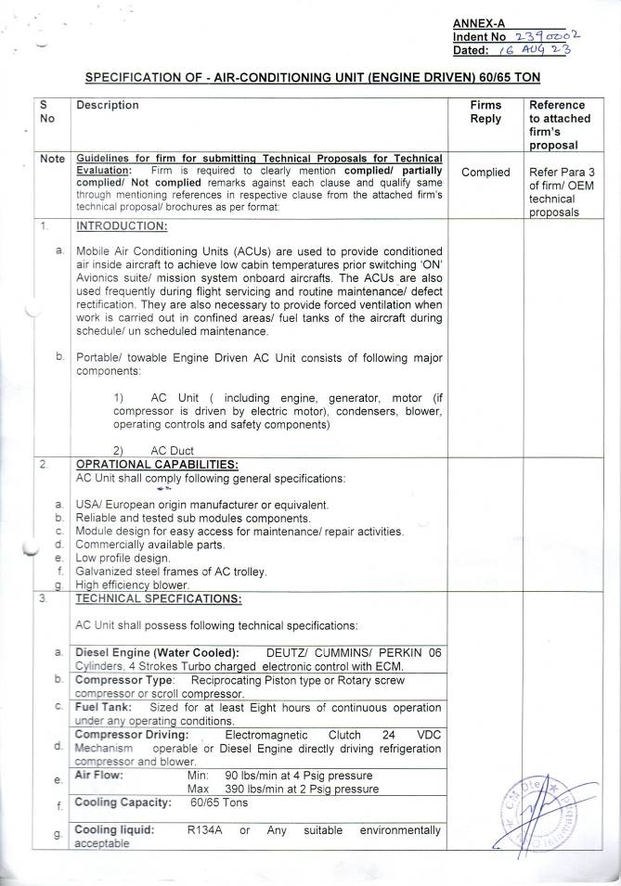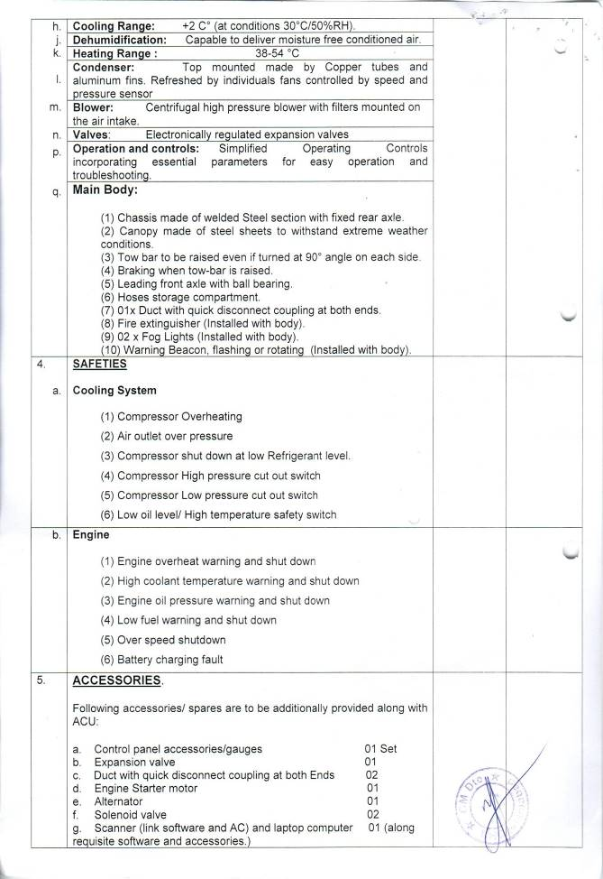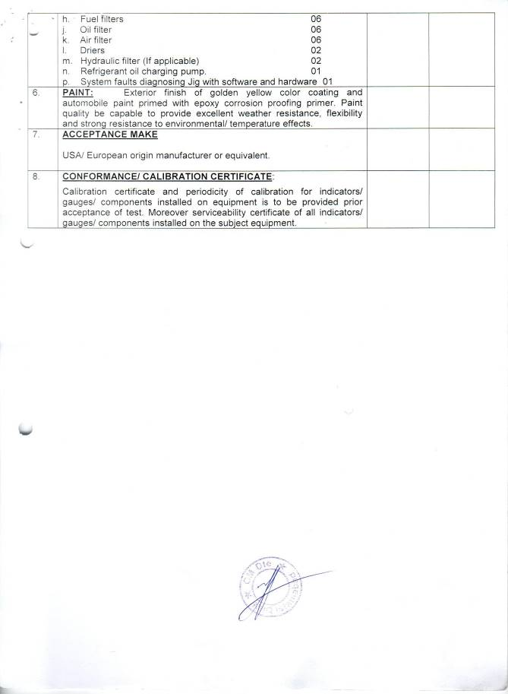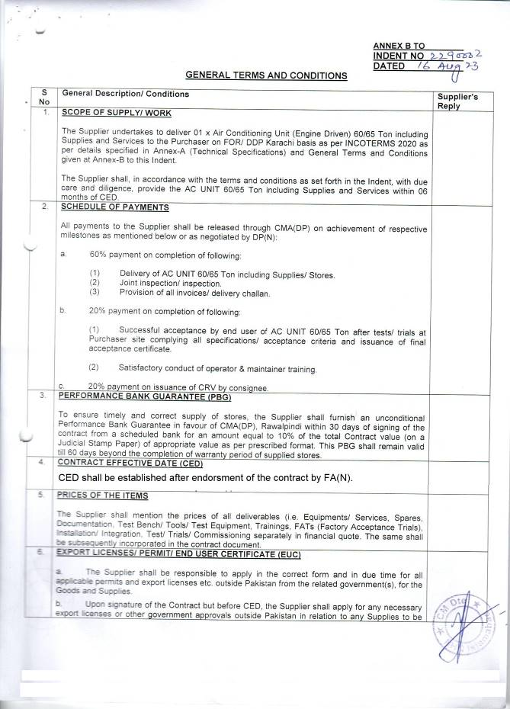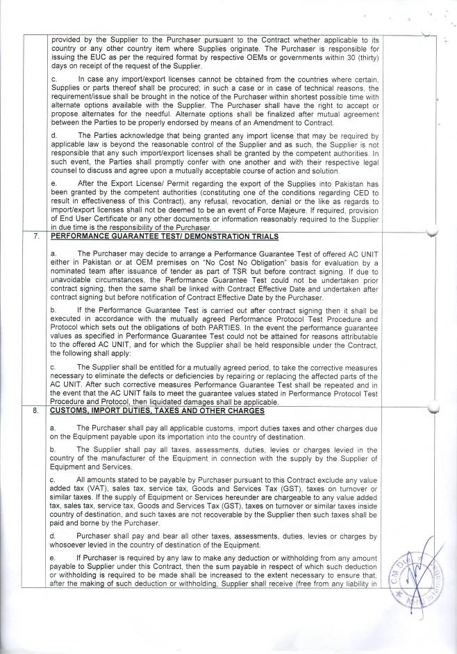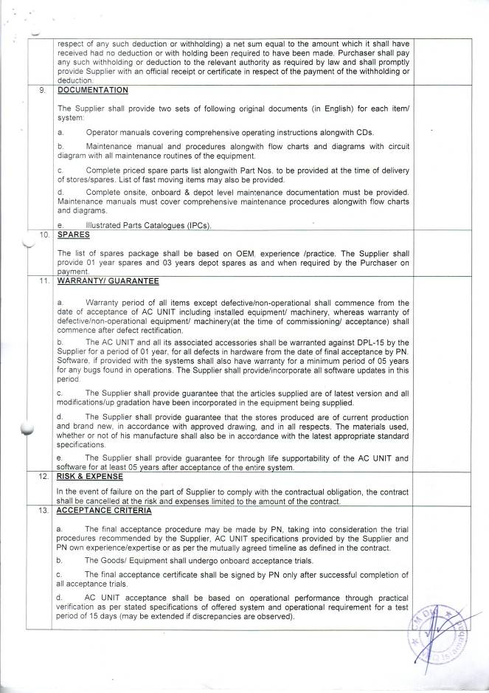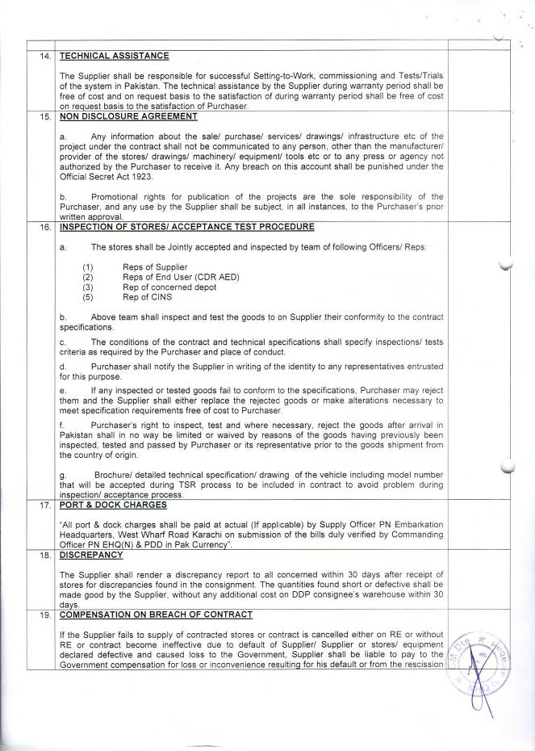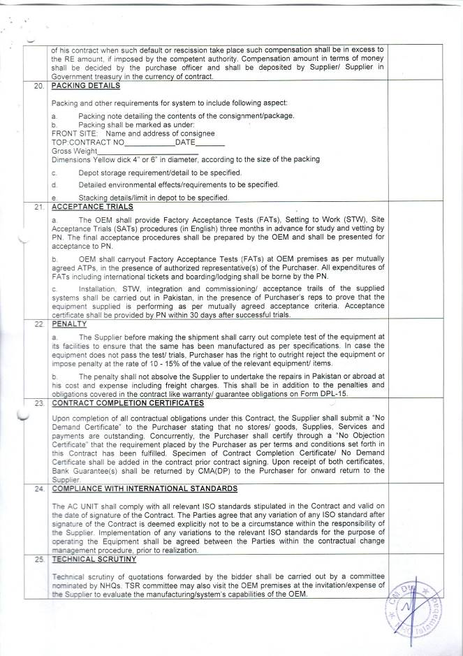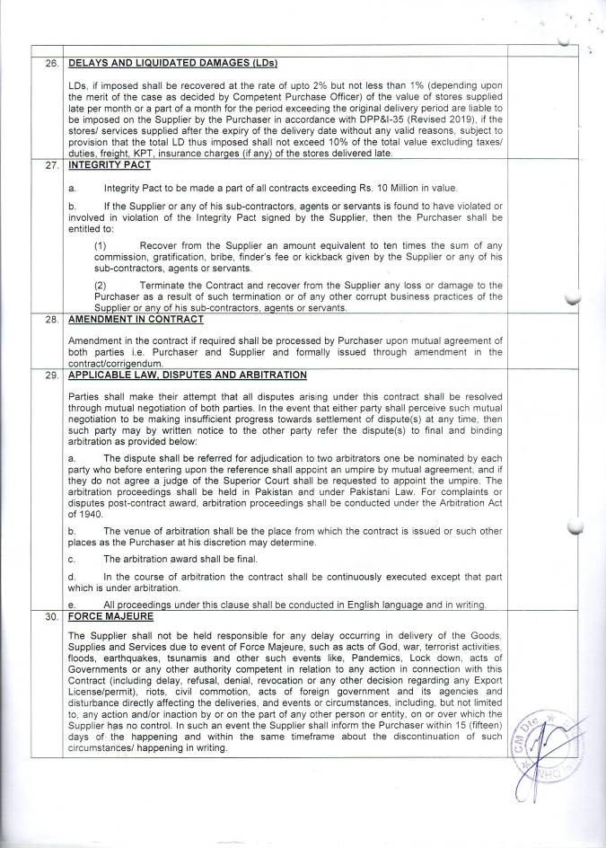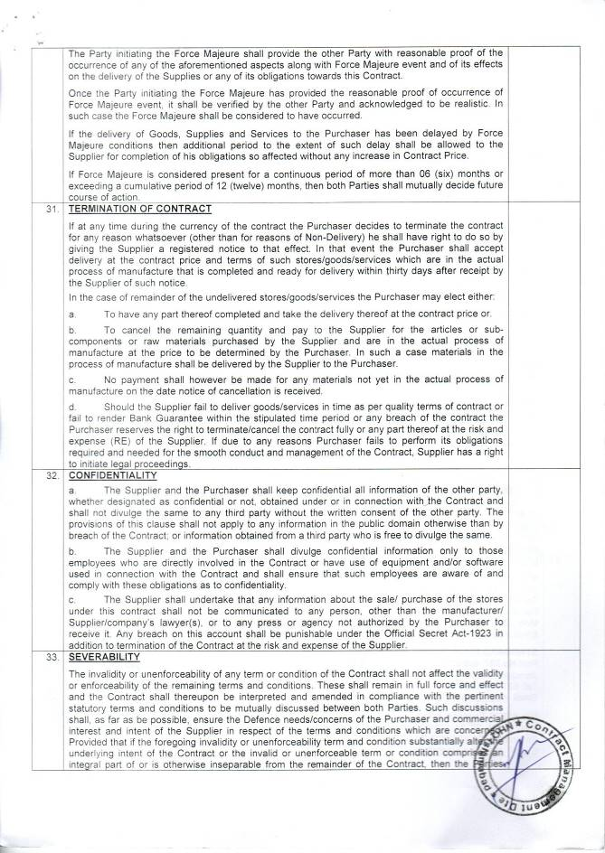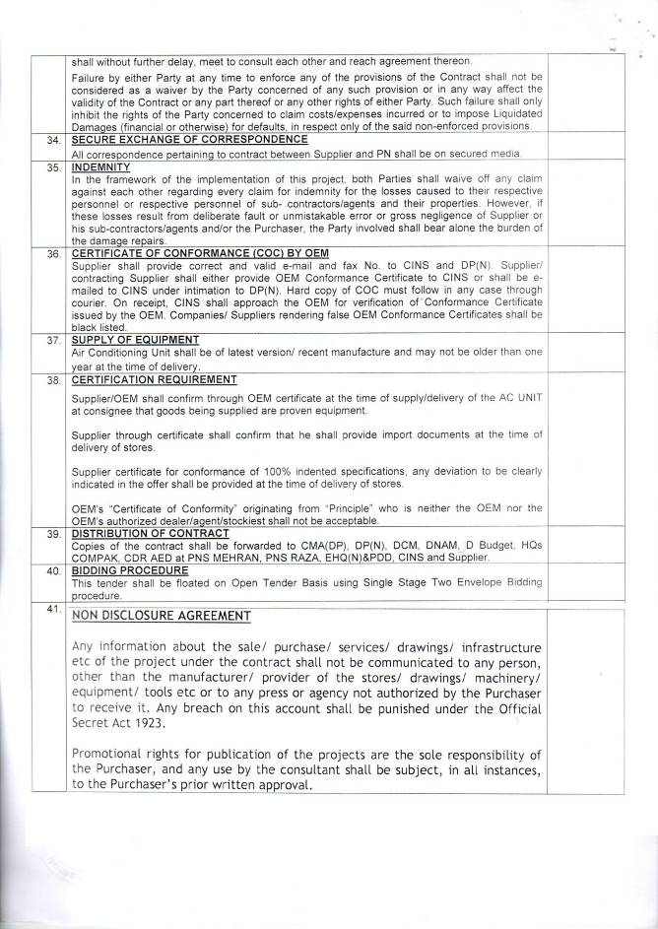

DP-3
Tender No…………… Name of the Firm………………
DGDP Registration No………..
Address…………………………
Telephone No. …………………
Official E-Mail…………………..
Fax No …………………….……
Mobile No ……………………...
To:
THE DIRECTOR OF PROCUREMENT
(Section P-32)
Through Bahria Gate
Near SNIDS Centre,
Naval Residential Complex, E-8,
Islamabad
Contact: Reception: 051-9262311
Bahria Gate: 331-5540649
Section: 051-9262302
Email: dpn@paknavy.gov.pk
adpn32@paknavy.gov.pk

Dear Sir Date_____________

1. I/We hereby offer to supply to the Director of Procurement (Navy) the stores detailed in schedule to the tender inquiry or such portion thereof as you may specify in the acceptance of tender at the prices offered against the said schedule and further agree that this offer will remain valid up to 120 days and will not be withdrawn or altered in terms of rates quoted and the conditions already stated therein or on before this date. I/we shall be bound by a communication of acceptance to be dispatched within the prescribed time.

2. I/We have understood the Instructions to Tenders and General Conditions Governing Contract in Form No. DP-35 (Revised 2002) included in the pamphlet entitled, Government of Pakistan, Ministry of Defence (Directorate General Defence Purchase) “General Conditions Governing Contracts” and have thoroughly examined the specifications/drawings and/ or patterns quoted in the schedule hereto and am/are fully aware of the nature of the stores required and my/our offer is to supply stores strictly in accordance with the requirements.

3. The following pages have been added to and form part of this tender:

a. ……………………………………….
b. ……………………………………….
c. ………………………………………..
Yours faithfully,
…………………………………
(Signature of Tenderer)
…………………………………….
(Capacity in which signing)
Address:………………………………..
Date……………………………….
Signature of Witness……………
Address…………………………………..

*Individual signing tender and/or other documents connected with a contract must specify:-

- Whether signing as “Sole Proprietor” of the firm or his attorney.
- Whether signing as a “Registered Active Partner” of the firm or his attorney.
- Whether signing for the firm “per procuration”.
- In the case of companies and firms registered under the Act, 1913 as amended up-to-
date and under the Partnership Act 1932, the capacity in which signing e.g.,
the Director, Secretary, Manager, Partner, etc. or their attorney and produce
copy of document empowering him so to sign, if called upon to do so.
(e) Principal’s Proforma invoice (in original)
(f) Earnest money
(g) Treasury Challan Form for tender Fees as applicable

NECESSARY DATA FOR ISSUANCE OF CONTRACTS ON BID SECURITY/EARNEST MONEY

IMPORTANT

Each column must be filled in with BLOCK CAPITAL LETTERS, incompletion shall render disqualification.

1. Name : _____________________________________

2. Father’s Name : ______________________________

3. Address (Residential) : _________________________________________________

_______________________________________________________________________

______________________________________________________________________

4. Designation in Firm : _______________________________________________________

5. CNIC : _____________________________________
(Attach Copy of CNIC)

6. NTN : ______________________________________
(Attach Copy of NTN)

7. Firm’s Address : __________________________________________________________

________________________________________________________________________

________________________________________________________________________

8. Date of Establishment of Firm : ________________________________________________

9. Firm’s Registration Certificate with FBR/Chamber of Commerce/Registrar of Companies.
(Attach Copy of relevant CERTIFICATE)

10. In case PARTNERSHIP (Attach particulars at serial 1,2,3,4,5 and 6 of each partner).

(Kindly fill in the above form and forward it under your own letter head with contact details)

